**System Test Procedure Specification**

* 1. **Test Case Specification Identifier**

TPS-03-01 2014-05-22

* 1. **Purpose**

This procedure describes the steps necessary to perform the test specified in the test design specification for PlasmaGraph TCS-03-01.

* 1. **Special requirements**

The tester must have knowledge of the system source code and access to it. Also, the tester must have Eclipse IDE installed as well as the testing framework JUnit.

* 1. **Procedure steps**

1. ***Open Eclipse***

The first step is to open Eclipse IDE.

1. ***Import PlasmaGraph Project***

To import the project right click on the Package Explorer and choose import.

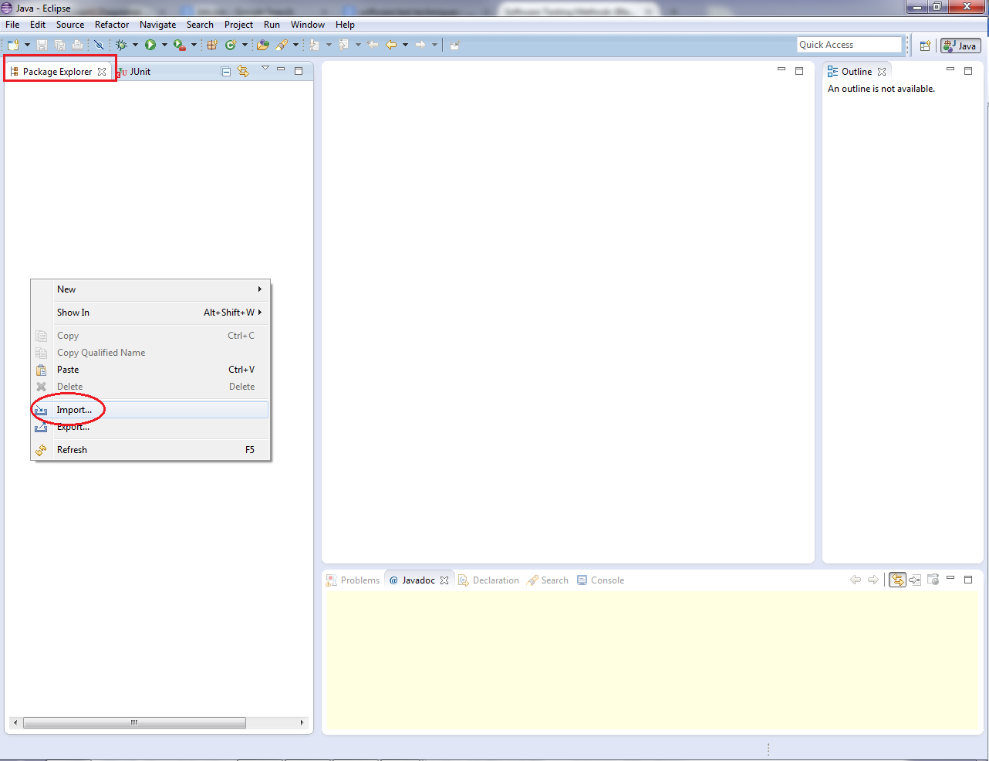

A window with several folders will appear. Select the folder called “General”, this will give you access to the options inside the folder. Choose “Existing Projects into Workspace” and click “Next”.

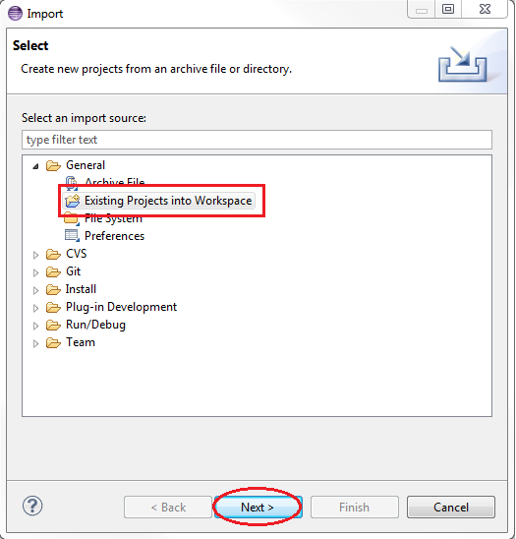

After clicking on next a new window with more options will appear. Click on the button that says “Browse…” located next to “Select root directory”. This action will prompt a window that you will use to select the directory where the source code of PlasmaGraph is.

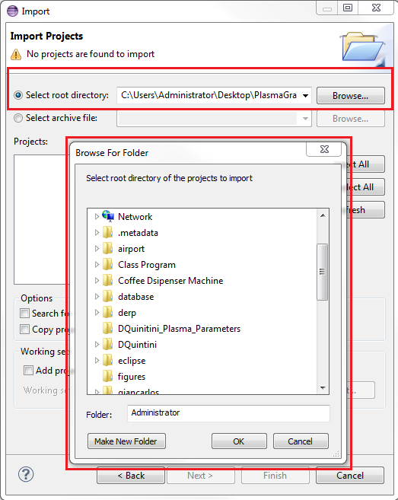

Now make sure that “plasmagraph” is selected under projects and click “Finish”.

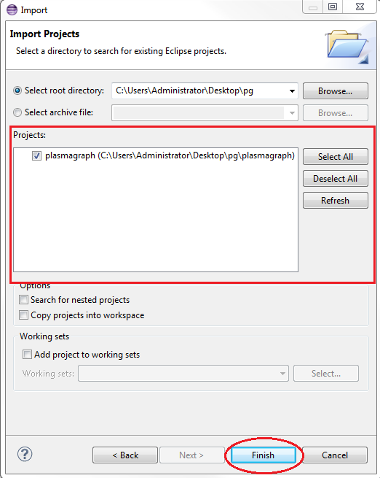

1. ***Run test suit***

To run the automated tests, go to the package explorer double click on plasmagraph to see what is inside the package. Then double click on src, org.pvg.plasmagraph.tests and finally right click on FeatureTestSuite.java.

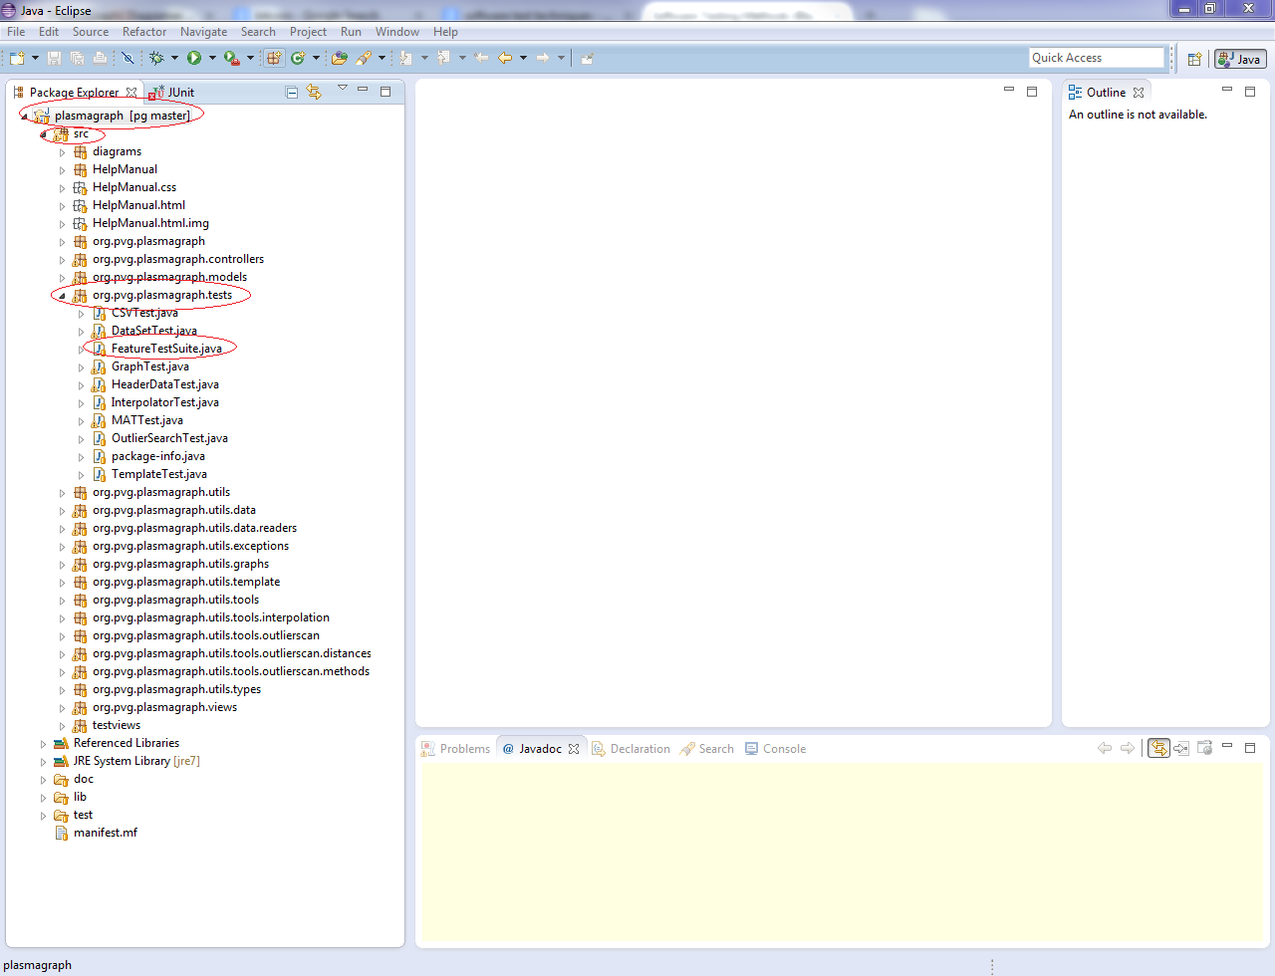

After right click on FeatureTestSuite.java a new menu window will appear. Choose “Run As >> JUnit Test”

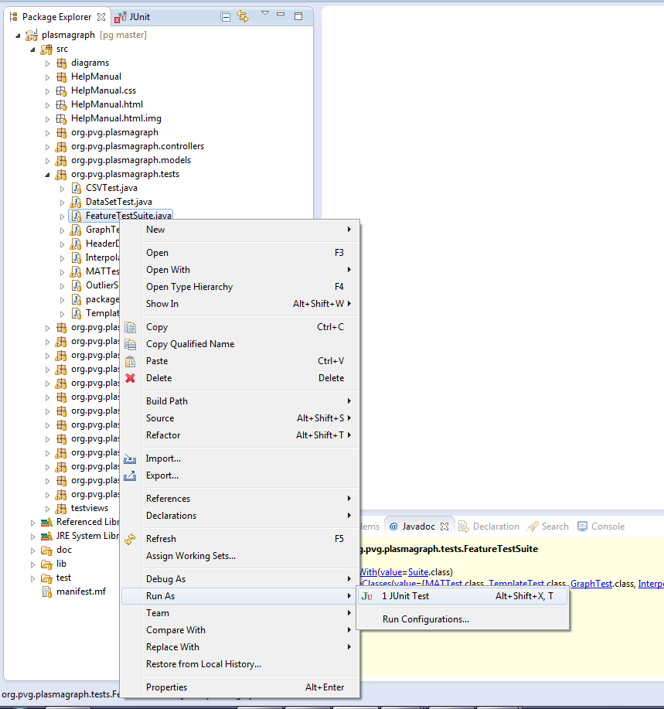

1. ***Compare outputs***

The tester must examine the output produced by JUnit and determine if it complies with the expected output specified in the test case specification for this case ***[see document TCS-03-01 section 4]***. To review this output click on the tab called “JUnit” located next to the package explorer tab.

